Clarke Street Improvements
Summary of phase community consultation, August 2020
Please see below a summary of community feedback received during the community consultation for the Clarke Street Improvements project:
What we heard
Community support for the trial of the Clarke Street Pop Up Park, Carmichael St bicycle connection and although a connection to the shared path is well supported further design considerations and consultation is requested for the Clarke Street and Cross Street intersection.

The community responded that they want to use the pop up park as a casual space to ‘hang out’ and as an event space. There was also interest in having playful elements in the space. Respondents requested seating as the most desired element in the park, followed by greening of the space. Play elements and shade also featured.
The community also brought up concerns in regards to the condition of the footpath and trees along the length of Clarke Street.

The survey was completed by the local community with the following breakdown:
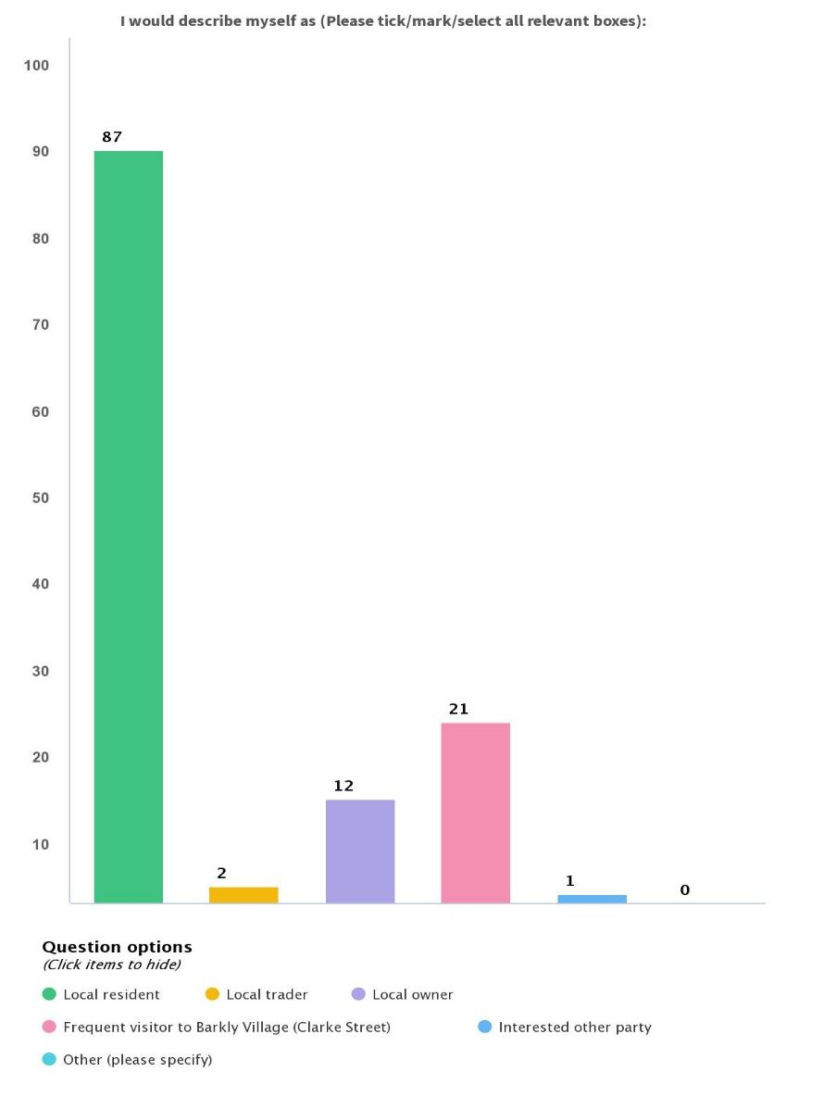

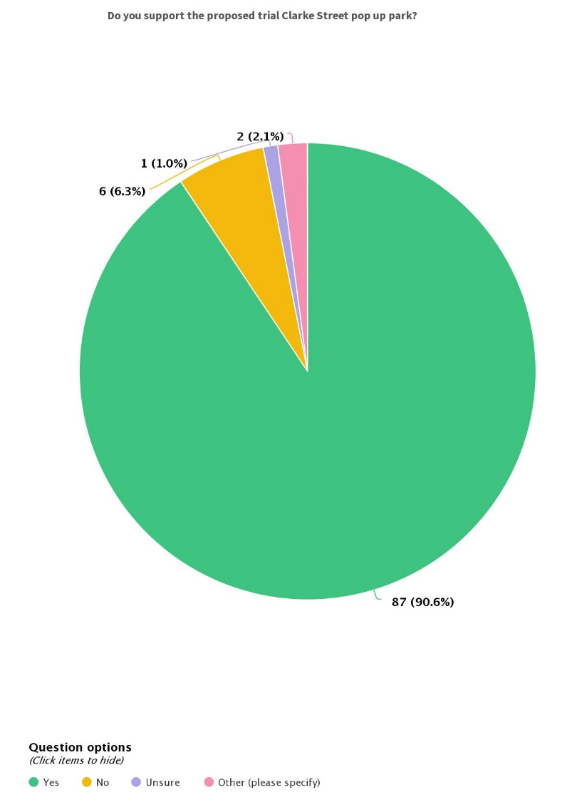

What was the outcome?

Council has endorsed the Clarke Street Improvements to progress into detail design. The design at Clarke Street and Cross Street is to progress with further consultation with the local neighbours and the bicycle advisory group.

Council has assessed the condition of the trees along the length of Clarke Street. A plan for renewal of some of the trees, footpath and road surfaces has been initiated. Council will be aligning tree renewal with road and footpath works to minimise disruption to the local community. Consultation with the local community will occur once a concept plan for the renewal works is completed.

What’s next?

Due to the strong support for the Clarke Street Pop Up Park and Carmichael Street bicycle connection we are progressing into detail design for these portions of the project.
Consultation on the cycling access to and through the park has taken place at the last meeting with Maribyrnong Active Transport Advisory Committee. Further consultation on the connection to the Cross Street shared path and changes to the intersection at Clarke Street and Cross St will be conducted after the caretaker period.
A renewal plan for Clarke Street has been initiated, which will address the condition of the trees and the footpaths and road surfaces. Local community consultation will be undertaken once a concept plan is created.

