Renaming part of Moreland and Maribyrnong Streets, Footscray.

Council wishes to obtain your view about renaming parts of Moreland and Maribyrnong Streets, Footscray.

Due to upcoming developments within the Joseph Road Precinct, Council is required to rename part of Moreland and Maribyrnong Streets, Footscray to assist with property number allocation within the Joseph Road Precinct.

Part of Moreland Street, Footscray
Hallenstein Street has been proposed for part of Moreland Street after Isaac Hallenstein, who was part owner of Michaelis & Hallenstein Co, one of the world’s largest tanneries which once stood in the Joseph Road Precinct.

Part of Maribyrnong Street, Footscray

It is proposed that the name Joseph Road is continued down Maribyrnong Street, as this area is predominantly known as the Joseph Road Precinct.

Parts of Moreland and Maribyrnong Streets, Footscray Location Plan

The part of Moreland Street, Footscray proposed to be renamed is located between Neilson Place and Hopkins Street, Footscray (as seen outlined in red on the map below).

The part of Maribyrnong Street, Footscray proposed to be renamed is located between Joseph Road and Hopkins Street, Footscray (as seen outline in blue on the map below).
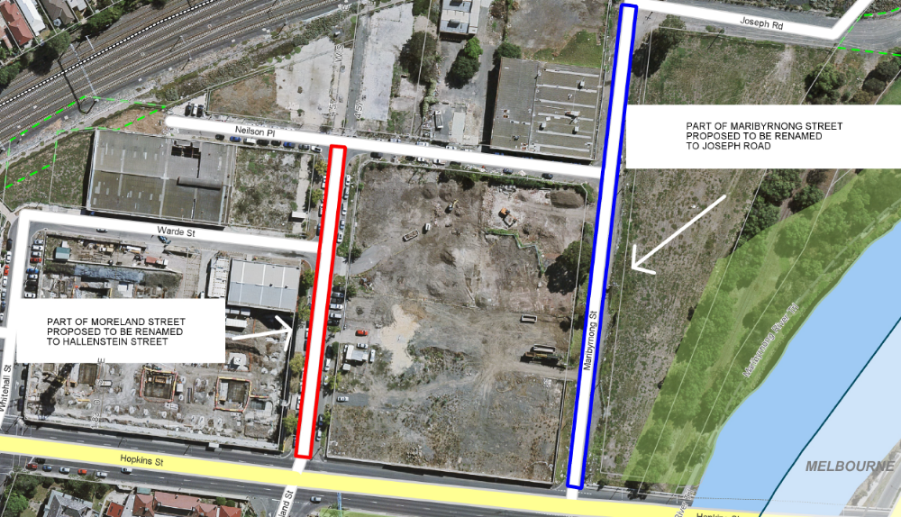
Road Naming Survey – Parts of Moreland and Maribyrnong Streets, Footscray.
Part Moreland Street, Footscray

The name proposed for part of Moreland Street is Hallenstein Street in recognition of the Michaelis & Hallenstein Co. The naming process follows the steps outlined in the State Government Guidelines for Geographic Names 2010.

Please answer the following questions:

- Do you approve the proposal to rename part of Moreland Street, Footscray which is between Neilson Place and Hopkins Street, Footscray (please circle)? YES / NO

- Do you support the proposed name Hallenstein Street (please circle)? YES / NO

Do you have any additional comments?
_______________________________________________________________________________________________________________________________________________________________________________________________________________________________________

Part Maribyrnong Street, Footscray

It is proposed that part of Maribyrnong Street is renamed to Joseph Road to form part of the current Joseph Road within the Joseph Road Precinct.

Please answer the following questions:

- Do you approve the proposal to rename part of Maribyrnong Street, Footscray which is between Joseph Road and Hopkins Street, Footscray (please circle)? YES / NO

- Do you support the proposed name Joseph Road (please circle)? YES / NO

Do you have any additional comments?
_______________________________________________________________________________________________________________________________________________________________________________________________________________________________________

Your Name: ___________________________________________________________________

Your Postal Address: ___________________________________________________________

Your Phone Number and or Email: ________________________________________________

Please complete the survey and return to Maribyrnong City Council by:

Post: Property Management Unit  Maribyrnong City Council  PO Box 58 Footscray, 3011 | OR | Email: email@maribyrnong.vic.gov.au

All comments must be received by Monday 23 January 2017, 5pm.

Non-return of surveys will be treated as consent for the proposed name.
For more information about the naming process, please contact the Property Management Unit by:
P: 9688 0151 or E: email@maribyrnong.vic.gov.au

