Thinking about why you would come to the hub – what concept size would you support?

LIKE for LIKE: Replace the current library with a similar size library (approx. $45m)

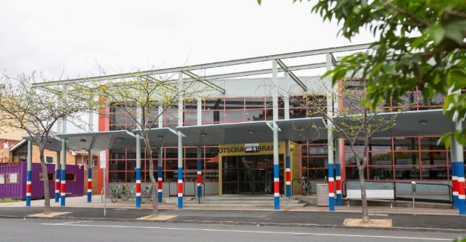
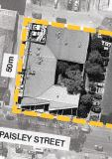
- Similar size to current library with capability to house current collection/ limited flexible spaces for community groups/ some digital improvement
- Children’s space integrated into the library
- No gallery space
- No performance venue
- No capability for community spaces/ tenancy/café or council offices
- Civic green space

SMALL: Medium library with a small performance space (approx. $79m)

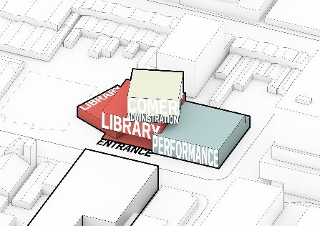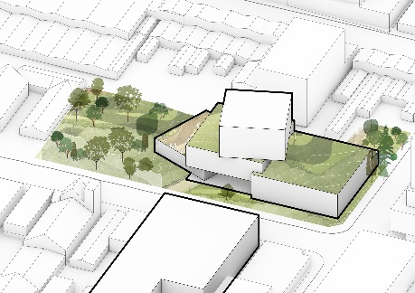
- Library with greater technological capabilities/flexible spaces – 80% larger than current library
- Dedicated children’s space
- Integrated display space/foyers
- Small performance venue; ≈300 seated & ≈550 standing
- Flexible community spaces to cater for ≈ 2 x small groups
- Min space for tenancy for café/community organisations
- Civic green space

MEDIUM: Medium library with media community and performance space (approx. $108m)
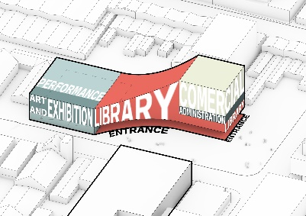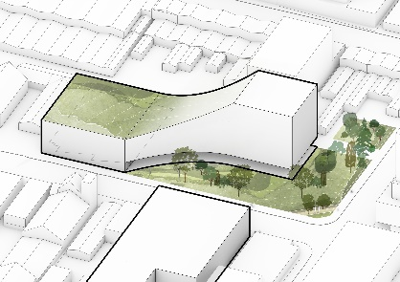
- Library with more advanced technological capabilities/flexible spaces – 130% larger than current library
- Dedicated children’s & youth spaces
- Dedicated gallery space for civic collection or exhibitions
- Medium performance venue; ≈400 seated & ≈670 standing
- Flexible community spaces to cater for ≈ 5 x small groups or 3 medium groups
- Capacity for an on-site café, tenancy & co-working spaces
- Civic green space
- Allowance for some Council administration functions

LARGE: Large library with extensive community and performance space (approx. $128m)

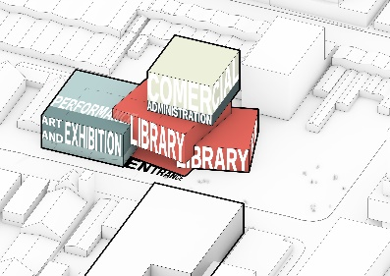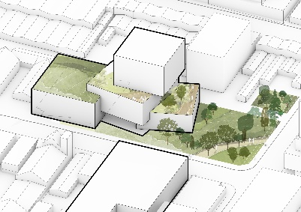
- Library with advanced technological capabilities/flexible spaces – 175% larger than current library
- Space to house collection & programmes to accommodate the predicted rate of population growth
- Dedicated children’s spaces & dedicated youth area
- 3 room gallery space for civic collection or exhibitions
- Medium performance venue; ≈500 seated & ≈900 standing
- Seated venue could include options for orchestra pit or ballet/opera large theatrical performances
- Flexible community spaces to cater for ≈ 10 x small groups or 5 x medium groups or 2 large groups
- Capacity for an on-site café, tenancy & co-working spaces
- Civic green space
- Allowance for some Council administration functions

