Other Parks you may like to consider whilst completing this survey:

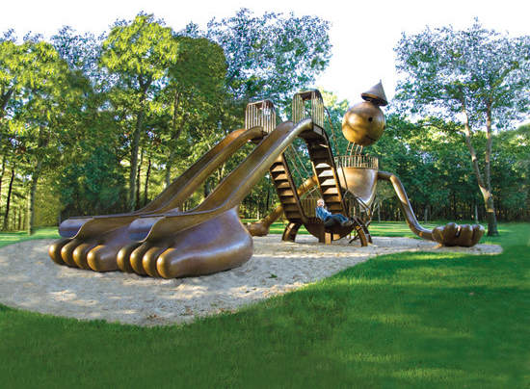
- Bronze play Sculpture, New York

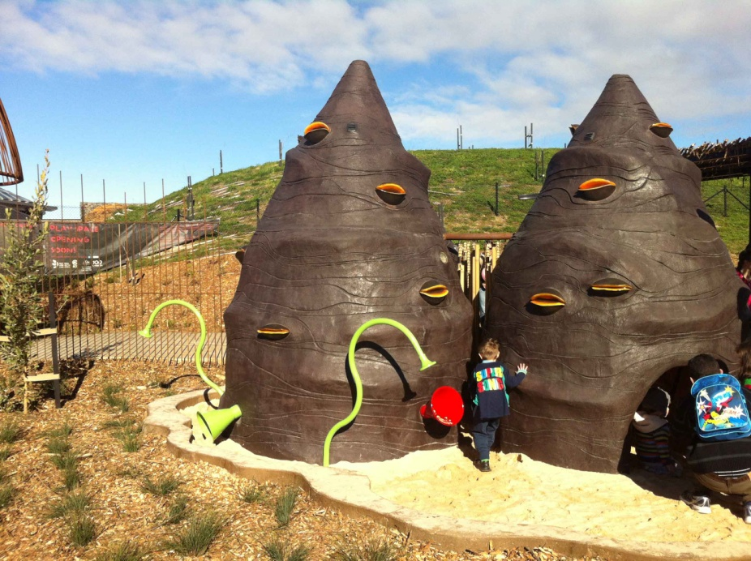

- Canberra Arboretum Play Space

- Children’s Garden – Royal Botanic Gardens Melbourne

