YOUTH IN YARRAVILLE
FREE ACTIVITIES LIVE MUSIC & MORE

Tuesday 12th January 12.00pm-2.00pm 2016
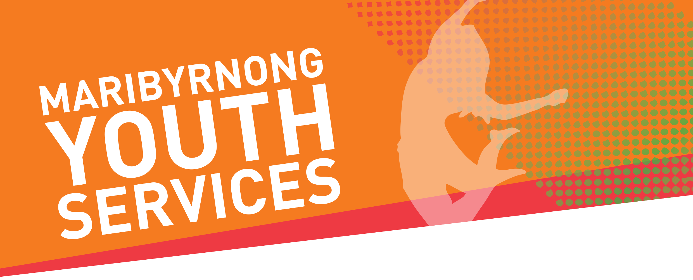
Come meet the Maribyrnong Youth Services team and what tell us what young people in Yarraville are thinking!

Pop Up Park
Ballarat Street, Yarraville
For more information please contact Maribyrnong Youth Services on 9091 4700 or phoenix@maribyrnong.vic.gov.au.

